Case 6-Afr-Burkina Faso-Mossi-Serpent Mask-20th century

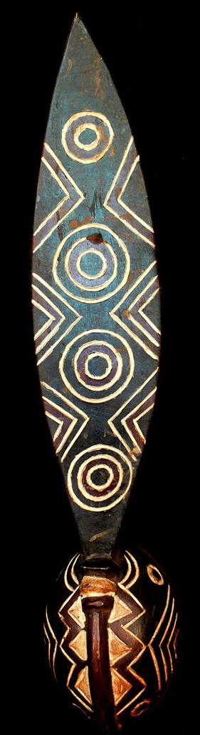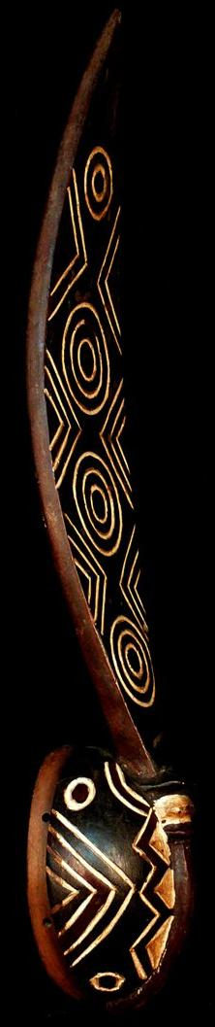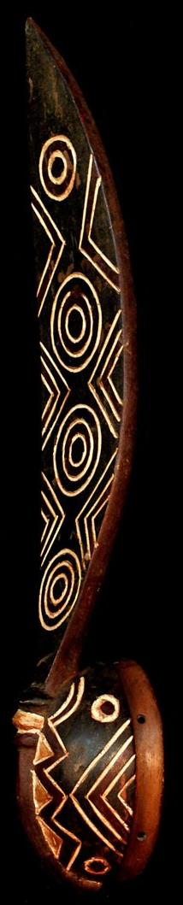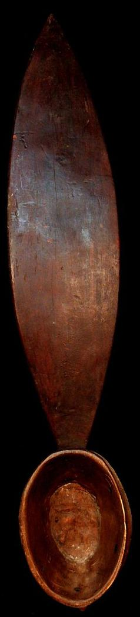
Afr-Burkina Faso-Mossi Serpent Mask-20th century
Display Description:
Exquisite and Rare Mossi Serpent Mask from Burkina Faso is worn in front of the face and is surmounted by a plank with concentric circles of the so-called Voltaic target motif prominently displayed as the markings of the body of a serpent (See artofburkinafaso.com/wp-content/uploads/.../Style-map-chapter.pdf).
The Mossi are today the largest single group living in Burkina Faso. They originated from horsemen who made their way north from present day Ghana during the 1500s. The Mossi are renowned for their masquerades and the use of large, superbly sculpted and brightly painted masks and colorful costumes. Mossi elders are highly honored with elaborate funerals and the appearance of masked dancers with masks representing ancestors and various spirits and forces of Nature in dramatic and often vigorous dances.
These animal masks are all representations of the totem animals for specific clans. In a clan village, the killing of an animal identified with the clan is the same as killing a person. Burkina Faso is a land of masks, with mask figures spread across all groups.
The serpent 1s one of several animals which are kept in sacred groves in this region. Within the enclosure the animals, which also includes the crocodile and the leopard, are respected, but they may be killed if they are outside of the sacred grove.
The python is in some localities regarded as the guardian of the village. The reptile contains a guardian spirit which will accompany a traveler on his journey if asked to do so. It is forbidden to cut down or even to gather wood in the sacred grove. Every attempt is made to prevent a stranger from violating the sacred wood, but if restraint is impossible, the people will offer a sacrifice on his departure.
Case No.: 6
Accession Number:
Formal Label: Afr-Burkina Faso-Mossi Serpent Mask-20th century
LC Classification: PL8005
Date or Time Horizon: 6000 BP
Geographical Area: Burkina Faso
Map:
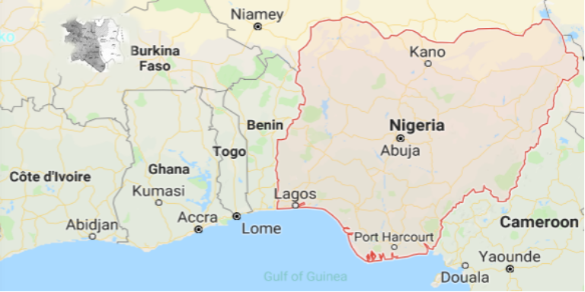
Location of the Mossi People (base map after https://www.google.com/maps/place/Nigeria).
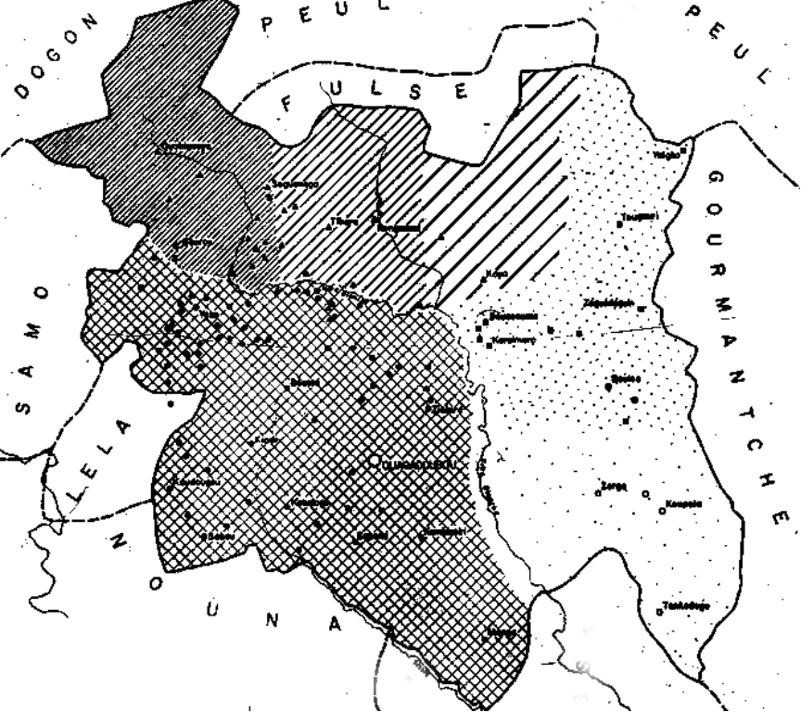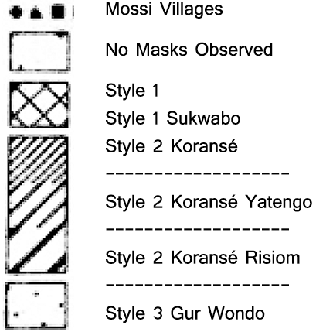
Mossi Mask Stle Map after https://africa.uima.uiowa.edu/assets/Uploads/mossi-mask-distribution-map.jpg

GPS Coordinates:
Cultural Affiliation: Bobo People
Medium: Wood, hematite and kaolin pigment
Dimensions: H 27.559 inches
Weight: 1.303 lbs
Provenance: Burkina Faso
Condition: Original
Discussion:
1 • Introduction
The Mossi make up the largest ethnic group in Burkina Faso. They are the second-largest ethnic group in Côte d'Ivoire (Ivory Coast).
At one time the Mossi were organized into three kingdoms, Tenkodogo, Wagadugu, and Yatenga. It is not clear when these were founded. However, a Mossi raid on the city of Timbuktu in 1329 is described in Arab histories. Each Mossi village had its own chief, and groups of up to twenty villages were ruled by a district chief. The political system of the Mossi was very closely connected to their religion. For this reason, the Mossi rulers resisted conversion to Islam.
The Mossi were one of the last peoples in Africa to be colonized. They were conquered by the French in 1896–97. French taxes forced many Mossi to move to Côte d'Ivoire to earn money. Mossi men could go south between crop-growing seasons and bring money back to their families in the north. They also traveled around as traders and as soldiers in the French army.
The Mossi homeland is the central portion of Burkina Faso, which was known until 1984 as Upper Volta. Burkina Faso has roughly the same area as the state of Colorado. The Mossi area, located in the center, runs from Tenkodogo in the southeast to Ouayagouya in the northwest. The country is mainly savanna, or grassland, with scattered trees. The few rivers and streams exist only in the rainy season. Only scattered pools keep water through the dry season. Most water used by the Mossi is drawn from wells.
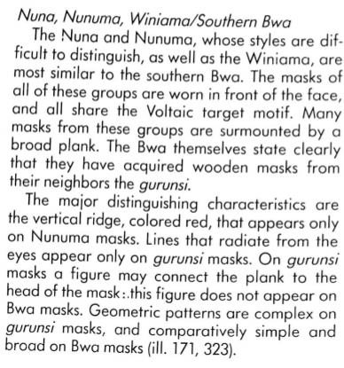

3 Language
The Mossi language is Moré. It belongs to the Gur group within the Niger-Congo language family. Like many African languages, Moré uses pitch (how high or low a tone is) to distinguish meanings. Also, as in other African languages, a verb form shows whether its action is continuing or happens only once.
4 •Culture
There have been few written records in Mossi society. Special singers, called griots, were the keepers of oral traditions. The entire society used folktales and proverbs to pass on wisdom and experience to later generations.
The Mossi's account of their founding is handed down through the following myth: Over forty generations ago, a king named Naba Nedega had a daughter whom he would not allow to marry because she was a great warrior. So Princess Nyennega took a horse and fled north into what is now Mossi country. She married a local man. Their son, named Ouedraogo (stallion), was sent back to his mother's homeland to be raised by his grandfather, Naba Nedega. When he grew up, he returned to the north with cavalry from his homeland and conquered his father's people, the Bisa. The marriage of Ouedraogo and his troops with Bisa women produced the Mossi people. A statue of Princess Nyennega on horseback in the city of Ouagadougou commemorates the story.
5 • RELIGION
The religion of the Mossi has three main components. There is a belief in an all-powerful creator, Wende; fertility spirits of the rain and the earth, which govern the soil and crops; and ancestors, who affect the lives of their descendants.
The fertility spirits are usually worshiped through animal sacrifices such as chickens or guinea fowl, which are held in sacred places. The ancestors watch over their descendants, punishing or rewarding them for their behavior. The yearly cycle of ceremonies is mainly about ancestors. Each household has a shrine to its ancestors, an upside-down pottery bowl with sacred plants and objects under it. This shrine is honored once a year, at the time of the harvest festival. Sacrifices and offerings are made to it and to the graves of male ancestors.
6 • MAJOR HOLIDAYS
Basegais a festival of thanksgiving that comes in December, after the millet crop has been harvested. The Mossi thank the ancestors for helping with the successful harvest, and they ask for help with the coming year's crops.
The Muslim community celebrates its own holidays, and the Christians celebrate theirs.
Since the revolution of 1983, its anniversary, August 4, has been the official national day. National holidays are celebrated with parades and, in towns and cities, bicycle races. The anniversary of the date of independence from France, August 5, 1960, is a secular (nonreligious) holiday in Burkina Faso. So is December 11, the anniversary of the proclamation of the Republic in 1958.
7 • RITES OF PASSAGE
From birth until death, major changes in a person's life are marked with formal rites of passage. A Mossi baby is formally presented to the community three days after birth for a boy, and four days after birth for a girl. At that time, the baby's name is announced. The child is formally welcomed into its family and takes the family name.
Before becoming adults, both boys and girls, in separate groups, are circumcised. Boys go in groups of fifteen to thirty to bush camps, where they stay for ninety to a hundred days to recover from the operation. At the same time, they are taught by older men the things they need to know to become members of society. Full adulthood is marked by marriage.
Mossi funerals are important family and religious events. Men are buried at the edge of their home, just west of the patio area outside the walled family compound. Women are buried in the fields of their husband's village, but the burial ceremony is performed by members of the deceased woman's own family (not by her husband's family). This symbolizes a woman's connection to her own family.
The funeral can occur up to a year after a burial and sometimes much later. The ceremony is what marks the passage of the dead person to the ancestors. The family must put on the funeral.
9 • LIVING CONDITIONS
The Mossi live in villages of extended families, that is, parents and children, plus other relatives. The village boundary may be a stream or other natural feature, but in general the village is a social unit more than a geographic one.
The traditional Mossi dwelling consists of a number of round adobe huts with cone-shaped, thatched roofs. They are surrounded with an adobe wall. (Today corrugated aluminum roofs are sometimes seen. They are something of a status symbol although they make the huts hotter and are noisier during rainstorms.) Each member of the extended family has a hut. Additional huts are used as kitchens, for storage, and as shelter for sheep, goats, and chickens. Each dwelling also includes a patio-like area of pounded, swept dirt with an awning. People rest there during the day and greet guests there. All houses face west.
10 • FAMILY LIFE
Marriage is usually arranged between families. At the time of a marriage, the wife's family receives payments from her husband and his kin. Traditionally, this bride-wealth was in the form of cattle and trade goods. Today, however, there are many possible types of payment. Nowadays it is not unusual for men and women who are in love to elope (run away and get married) if they cannot convince their families to agree to the marriage.
Within the walled area of the Mossi home, each wife has her own hut for herself and her children. There she prepares meals for herself and for them. If the husband has more than one wife, he joins each of them for meals in turn. Although many Mossi men have only one wife, there are two reasons wives often want their husbands to have more than one. First, it is useful to have another wife to help with laborious housework. In addition, another wife can give moral support and companionship.
Children have important roles in tending the family's sheep and goats. They also help haul water and gather firewood for cooking.
11 • CLOTHING
Mossi women wear long skirts made of a cloth panel wrapped around the waist. It is common to wear a top as well, but until recently this was not the case in rural areas. It is more and more common for men to wear shirts and trousers of Islamic or European style. Wealthy men and chiefs still wear the traditional embroidered robes in the Muslim-influenced style of the savanna.
There is also a major business of selling used American clothing, even in rural markets. Today the everyday working outfit of a farmer is likely to be a woven shirt and a pair of cutoff blue-jeans. Rubber shoes and sandals have been added to the traditional leather ones.
12 • FOOD
The staple of the Mossi diet is the millet grain, along with its relative, sorghum. Millet is ground into flour and made into porridge by boiling it in water. The bowl of thick, doughy food is called sagabo in Moré and tô in West African French. One eats it by breaking off a piece with the right hand and dipping it into a sauce made of vegetables, spices, herbs, and, sometimes, meat. Sorghum is used to brew a beer similar to cider that is drunk by all Mossi.
Meat is a luxury and is usually added to sauces in small amounts. Grilled meat is for special celebrations.
Mossi often have food taboos, which tend to vary from clan to clan.
13 • EDUCATION
In traditional Mossi society, most education came from living with, watching, and helping more experienced, older people. The circumcision camps provided a few months of group schooling to boys.
14 • CULTURAL HERITAGE
Music has been important to Mossi societyand is used to set rhythms for agricultural tasks such as hoeing and threshing. The main musical instruments are drums. Some are large calabashes (a type of gourd) with leather drumheads and are played with the hands. There are also wooden drums played with sticks. The player can change a drum's pitch by changing arm pressure on the strings tying the head to the drum. There are also flutes and stringed instruments.
Some Mossi, but not all, have traditions of masked dancing at ceremonies such as funerals.
Griots (traditional storytellers) recited family histories and traditions at weddings and other events.
18 • CRAFTS AND HOBBIES
Pottery is made by only one clan of potters and drummers.
For the Mossi communities that have masked dancing, the carving and painting of masks is a major art form. Mossi masks are part of most major collections of African art.
Read more: https://www.everyculture.com/wc/Brazil-to-Congo-Republic-of/Mossi.html#ixzz5cmKgmXif

References:
Coffman, R. J., 1992. Burkina Faso Notebooks. MS.
Decalo, Samuel.Burkina Faso.World Bibliographical Series, vol. 169. Oxford, England; Santa Barbara, Calif.: Clio Press, 1994.
Greenberg, Joseph H., 1966. The Languages of Africa (2nd ed. with additions and corrections). Bloomington: Indiana University.

Guirma, Frederic.Tales of Mogho: African Stories from Upper Volta.New York: Macmillan, 1971.
Internet Africa Ltd. [Online] Availablehttp://www.africanet.com/africanet/country/burkina/, 1998.

Koloss, H.J. ed., 2002. Africa: Art and Culture: Masterpieces of African Art, Ethnological Museum, Berlin (Vol. 1). Prestel Pub.

Roy, C.D. and Chaffin, A., 1987. Art of the Upper Volta rivers. Meudon: A. et F. Chaffin

Skinner, Elliott P. 1989. The Mossi of Burkina Faso: Chiefs, Politicians, and Soldiers. Prospect Heights, Ill.: Waveland Press.
Wheelock, T.G. and Roy, C.D., 2007. Land of the Flying Masks: Art and Culture in Burkina Faso; the Thomas GB Wheelock Collection. Prestel Pub.

Appendix
Price:
US $1,640.00

